Dishes and their allergen content Christmas Dinner Day 18.12.24
(Note – Please state the name of the cereal(s) containing gluten* and/or the name of the nut(s)†)

Dishes | 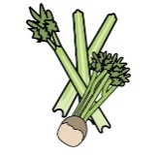 | 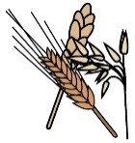 | 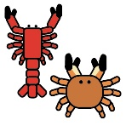 | 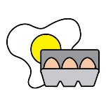 |  | 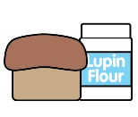 | 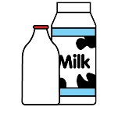 |  | 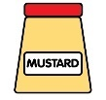 | 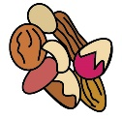 | 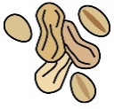 | 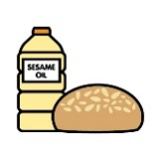 |  | 
 | Celery | Cereals containing gluten* | Crustaceans | Eggs | Fish | Lupin | Milk | Mollusc | Mustard | Nuts† | Peanuts | Sesame seeds | Soya | Sulphur Dioxide
Turkey Roast dinner with Stuffing, Pigs in Blankets & Roast Potatoes | X | X - Wheat |  | X |  |  | X |  |  |  |  |  |  | X
Christmas Tub filled with Vanilla & Chocolate Ice cream |  |  |  |  |  |  | X
Ham Sandwich |  | X - Wheat |  |  |  |  | X |  |  |  |  |  | X
Cheese Sandwich |  | X - Wheat |  |  |  |  | X |  |  |  |  |  | X
Tuna Mayonnaise Sandwich |  | X - Wheat |  | X | X |  | X |  |  |  |  |  | X
Quorn Dinner with Stuffing and Roast Potatoes | X |  |  | X |  |  | X

Review date: | 29.11.24 | Reviewed by: | Hannah Greenway |  |  |  | You can find this template, including more information at www.food.gov.uk/allergy-guidance

